Manish
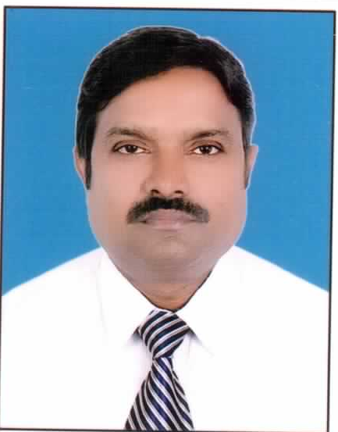

Phone no : +91-8469073335, +91-8130171216

E-mail: manishkrsingh123@gmail.com
Brief Overview
- Comprehensive 18 years’ experience in the sphere of Power Plant, Residential, Commercial and Industrial Construction.
- Proficient in Basic Engineering, Project Planning & Management, Execution and developing strategy for achieving objective of project.
- Outstanding PR skill and ability to motivate the team to achieve the target within time / schedule and cost.
Professional Qualification: B.E. (Civil) Amravati University Maharashtra (1997) with 1st division

Work Experience

Summary of Responsibilities Handled
- Directed and managed project development from beginning to end.
- Defined project scope, goals and deliverables that support business goals in collaboration with senior management and stakeholders.
- Developed full-scale project plans and documented associated communications.
- Effectively set and communicated project expectations to team members and stakeholders in a timely and clear fashion.
- Liaise with project stakeholders on an ongoing basis.
- Resources estimation, including manpower needed to achieve project goals.
- Prepare and submit budget proposals, and recommend subsequent budget changes wherever necessary.
- Delegated tasks and responsibilities to appropriate personnel.
- Identified and resolved issues and conflicts within the project team.
- Identified and managed project dependencies and its critical path.
- Plan and schedule project timelines and milestones using appropriate tools.
- Track project milestones and deliverables.
- Progress reports, proposals, requirements documentation, and presentations.
- Define project success criteria and disseminate them to involved parties throughout project life cycle.
- Coach, mentor, motivate and supervise project team members and contractors, and influence them to take positive action and accountability for their assigned work.
- Conducted project post mortems and create a recommendations report in order to identify successful and unsuccessful project elements.
- Developed and implemented best practices at site for smooth/speedy project execution and management.
- Ensured full compliance of all prevailing laws, acts and government notifications during project life cycle.

Jones Lang LaSalle Property Consultants (India) Pvt Ltd (March 2015 to June 2016)
Working as Sr. Project manager (PMC) for construction of Hero Moto Corp Manufacturing plant at Halol, Baroda, Gujarat. Looking after overall construction and commissioning of plant from mobilization of the project till date. My role is of Monitoring/ Supervision and coordination with Client / Consultant / Contractor for smooth and speedy comissioning of plant with at most satisfaction of client. Scheduled completion of the projects was in July 2016.Overall cost of plant is 1800 Cr in which estimated civil and structural work cost is 384 Cr. Built up area of the plant is of 124000 Sq. m on acquired land of 204 acres.

Simplex Infra structure Ltd (June 2014 to February 2015)
Sr Project Manager Execution (reliance refinery at Jamnagar Gujarat).
As In-charge of cooling tower and Utility package done planning & Execution of these package. I had handle material and resource management for execution of these packages. Majority of structures are completed like foundation of pipe rack, Air Compressor, Air Receiver, Air Blower, Re-Mineralization Plant, De-Mineralization Package, Air Receiver Foundation , Cooling Tower and others area of OSBL and ISBL OF C2 Complex having total cost of 600 Cr. which include structural fabrication erection and civil works.

JMC Projects (I) Ltd (November 2008 to May 2014)
Sr. Manager (Project coordinator, PMG) at Regional Office Noida
- NTPC CHP 2x590 MW, Dadri (U.P).
- NTPC CHP 2x600 Mw, Mauda, Nagpur (M.H).
- RINFRA 2x660 MW SASAN, (M.P).
- Thermal Power Project Sikka Gujrat ( BHEL)
- TPP Sasan, M.P (RINFRA)
- AIIMS Karnal, Haryana.
- AIIMS Raibareli, U.P.
- Liaison with Consultants, Contractors and Architects for drawing and constraints.
- Review of budget and billing for the projects.
- Planning, executing material management for site activities.
- Making timely decision for smooth functioning of the project.
- Technical & commercial discussions with the vendors.
- Comparative analysis with profitability for finalization of purchase orders.
- Monitor schedule of project to keep them on track.
- Submission of MIS reports to Management.
- Assemble, lead, and manage a team of internal & external professionals for smooth execution of projects.

Desein Pvt Ltd. (May 2006 to October 2008)
Manager (PMC) for Raj-West Lignite Thermal power plant of 8X135 MW Capacity Barmer, Rajesthan.
- Liaison with Consultants, Contractors and Architects.
- Review of budget for the projects.
- Monitor schedule of project to keep them on track.
- Making timely decision on constraints for smooth functioning of the project.
- Planning, executing site activities and billing of contractors.

Reliance Energy Limited (September 2003 to May 2006)
Sr Engineer for Thermal power plant, Panipat (2X250 MW capacity) Haryana.
Sub-Station of 33 KVA and 66KVA for Delhi DISCOM
- Hard-core execution of the project from Mobilization till Handing-over
- Planning, executing site activities and making timely decision for smooth functioning of the project.
- Review of budget for the projects as well as contractors billing.

Satish Enterprises Pvt. Ltd. (June 1997 to August 2003)
Site Engineer for IOCL site Office and Residential Complex at Surat, Gujarat.
- Hard-core execution of the project from Mobilization till Handing-over
- Planning, executing site activities and making timely decision for smooth functioning of the project.
Site Engineer (Execution)

Personal Details
Father Name : Shri. Mahesh Prasad
Marital Status : Married
Date of Birth : 04-02-1973

Extra-Curricular
- Participating in various Self-Development training programs on Public Speaking, Communication Skills, Memory, and Mind Science etc.
- Participated in various training program for construction safety.

MANISH
Correspondence Address
House No:101, Lumbni Apartment, Sector: 14,
Kaushambi, Gaziabad, U.P

